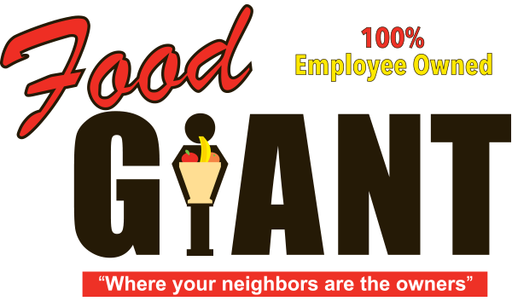

**COT 6931 Progress Report 1**



Food Giant Sales Flyer Generator

**Student - Kendrick Hagerman**

**Client - John Webb**

**Date: 2/26/2017**

**Dates Covered: 1/09/2017 - 2/26/2017**

Table of Contents

Project Background: 2

Terms of Reference & Key Objectives 2

Terms of Reference 2

Key Objectives (from SRS) 3

SRS001 3

SRS002 3

SRS003 3

SRS004 3

Discussion of achievements since last reporting 3

Discussion of problems that have arisen 3

Discussion of work that lies ahead 4

Assessment of whether you are on target 4

Risk Assessment Update 4

Update Time Schedule 4

# Project Background:

The project came about during a discussion with a high-school friend of mine, John Webb. I was looking for a project to work on and he presented this idea.

Six division managers at Food Giant (a grocery chain) want a program for their store managers that will help them quickly create sale flyers based on items these store managers select. Food Giant already has global sale flyers but these are made and shipped from corporate. The division managers want the store managers to be able to quickly print custom flyers for perishable items they have excess stock in to help sell these items before they expire. This will help them to sell excess stock at a store and increase revenue.

Prior to me accepting the project, the managers met with a 3rd party development team in order to get the program created, but the team’s budget was too high, and the project was never started.

The eventual outcome of this project is to allow store managers to have more control over their items’ sale price so they can sell items at a lower price before they have to throw away the expired inventory. Eventually, this program could potentially replace how they create flyers (they manually create flyers by using a simple design program) to allow the company to have higher quality flyers like larger grocery chains, like Publix.

# Terms of Reference & Key Objectives

## Terms of Reference

|  |  |
| --- | --- |
| Term | Definition |
| ASP.NET | Active Server Pages |
| GUI | Graphical User Interface |
| MVVM | Model View View-Model |
| QA | Quality Assurance |
| SDD | Software Design Description |
| SPMP | Software Project Management Plan |
| SQL | Structured Query Language |
| SRS | Software Requirements Specifications |
| STD | Software Test Document |

## Key Objectives (from SRS)

Please see Hagerman_Kendrick_Software_Requirements_Specification.docx for details and sub requirements for SRS items.

### SRS001

Implement a program as a GUI that allows a store manager to select from one or more template types and categorized items created from a database.

### SRS002

Create a SQL database used to store Food Giant data.

### SRS003

Deploy this program onto a server that the store managers, division managers and division manager’s assistants can log in to in order to print a flyer, add a new product and associated images, or add a new flyer template.

### SRS004

Create a User Guide for the Food Giant Flyer program

# Discussion of achievements since last reporting

Since this is the first project report, there have been many objectives. Here is a list of achieved objectives:

* Completed all items in project definition
* Discussed proposed requirements with client multiple times and compiled these requirements in early SRD
* Completed research into potential design strategies and programs for Flyer and decided on final suite of programs for achieving these design strategies and program.
* Started early design documentation of final layout
* Created first draft of project schedule and sent to client
* Started early prototype of UI with MVVM layout
* Created Source Control Git repository on Github, allowing me to have source control on project and documentation. Also, provides a complete detailed history of work done

# Discussion of problems that have arisen

* Difficult to get face-to-face meetings with stakeholders due to school and work. Main stakeholder (John) lives over an hour away and works 6 days a week, usually on weekends.
* Difficulty in communicating technical requirements to stakeholder. I’m still not sure how they want this program deployed, only that they do.
* Budget concerns – though I am working for free due to school, the stakeholder will still need to spend money to host the program and database for their customers, and I do not know what their budget is for that.
* Other stakeholders – I have not talked to other 5 division managers and do not know their goal. I am presenting my prototype to all of them in April, which could quickly turn chaotic if they have disagreeing ideas. Logged as risk.

# Discussion of work that lies ahead

* Complete prototype and refactor multiple times to establish layouts before April meeting
* Complete design documents on programs
* Complete actual program implementation
* Host program on a server-side system and test
* Complete test cases
* Complete all other minimum project artifacts - (SPMP, SRS, User’s Manual, QA plan, test cases, etc.)

# Assessment of whether you are on target

* Currently, I am not sure if I can complete all documentation required on top of prototype. I will need to communicate more with stakeholder to make prototypes more productive and possibly use leave at work so I can complete documentation assignments.

# Risk Assessment Update

Please see the attached Hagerman_Kendrick_Risk_Mitigation and Hagerman_Kendrick_Risk_Matrices files

# Update Time Schedule

Please see the attached Hagerman_Kendrick_Schedule